Chapter 4 Series Solutions
1 Power Series Method

1.1 Power Series
a_{m} ( x − x₀ )^{m} = a₀ + a₁ ( x − x₀ ) + a₂ ( x − x₀ )² + . . .
where a₀, a₁ , . . ., are constants (coefficients)
x₀ is a constant (center)

Taylor's Formula
f(x) = ^{m} + R_{N} (x − x₀)
If (x − x₀) is sufficiently small, R_{N} (x − x₀) → 0 as N → ∞, then, we say f(x) is analytic at x₀, and
f(x) = ^{m} Taylor Series
When x₀ = 0 ⇒ Maclaurin Series

Examples: e^{x} = = 1 + x + + + . . .
sin x =
cos x =
Please read Textbook for other examples.

1.2 Basic Idea of the Power Series Method

In the previous discussion, the linear differential equations with constant coefficients were solved and shown to have solution for
They can be anyone of the following 3 forms:
But, exponential, sine and cosine functions can be expressed in terms of Maclaurin series or Taylor series expanded around zero.

[Example] y'' + y = 0
[Solution] Assume
y = a_{m} x^{m} = a₀ + a₁ x + a₂ x² + . . .
y' = m a_{m} x^{m-1} = a₁ + 2 a₂ x + 3 a₃ x² + . . .
y'' = m ( m - 1 ) a_{m} x^{m-2} = 2a₂ + 6 a₃ x + 12 a₄ x² + . . .
Since y'' + y = 0
⇒ (2a₂ + 6a₃ x + . . .) + (a₀ + a₁ x + a₂ x² + . . .) = 0
or (2a₂ + a₀) + (6a₃ + a₁) x + (12a₄ + a₂) x² + . . . = 0
Since 1, x, x², . . ., x^{n} are linearly independent functions, we have
2a₂ + a₀ = 0 coefficients of x⁰
6a₃ + a₁ = 0 coefficients of x¹
12a₄ + a₂ = 0 coefficients of x²
or a₂, a₄, a₆, . . ., can be expressed in terms of a₀
a₃, a₅, a₇, . . ., can be expressed in terms of a₁
where a₀ and a₁ are arbitrary constants. After solving the above simultaneous equations, we have
a₂ = − = −
a₃ = − = −
a₄ = . . . = ; ...
thus y = a₀ + a₁
= a₀ cos x + a₁ sin x

- Since every linear differential equation with constant coefficients always possesses a valid series solution, it is natural to expect the linear differential equations with variable coefficients to have series solutions too.
- Also, since the majority of series cannot be summed and written in a function form, it is to be expected that some solutions must be left in series form.

y'' + p(x) y' + q(x) y = 0
where p(x) and q(x) are expressed in polynomials.

We assume
y = a_{m} x^{m} = a₀ + a₁ x + a₂ x² + . . .
y' = m a_{m} x^{m-1} = a₁ + 2 a₂ x + . . .
y'' = m ( m − 1 ) a_{m} x^{m-2} = 2 a₂ + 3 × 2a₃ x + . . .
- Put y, y' and y'' into the differential equation
- Collect terms of x⁰, x¹, x², . . .,
- Solve a set of simultaneous equations of a₀, a₁, a₂, ....

2 Theory of Power Series Method

2.1 Introduction
Power Series:
S(x) = a_{m} ( x − x₀ )^{m} = a₀ + a₁ ( x − x₀ ) + a₂ ( x − x₀ )² + . . . (1)
Partial Sum:
S_{n}(x) = a₀ + a₁ ( x − x₀ ) + a₂ ( x − x₀ )² + . . . + a_{n} ( x − x₀ )^{n} (2)
Remainder:
R_{n}(x) = a_{n+1} ( x − x₀ )^{n+1} + a_{n+2} ( x − x₀ )^{n+2} + . . . (3)

Note that R_{n} = S − S_{n} or | S_{n} − S | = | R_{n} |

Convergence:

Definition 1
If limS_{n}(x₁) = S(x₁), then the series (1) converges at x = x₁ and
Definition 2
If the series converges, then for every given positive number ε (no matter how small, but not zero), we can find a number N such that
| S_{n} − S | < ε for every n > N

2.2 Radius of Convergence

We know that for the series
x^{m} = 1 + x + x² + . . .
|x| > 1 divergent
|x| < 1 convergent
but for the series
= 1 + x + + . . . ( = e^{x} )
convergent for all x.

If a series converges for all x in
| x − x₀ | < R
and diverges for
| x − x₀ | > R (0 < R < ∞)
then R = radius of convergence
R = ∞ if series converges for all x.

R can be calculated by the following formula:
R =
or R = (Ratio Test)

Ratio Test
ρ = lim
= lim
if ρ > 1 divergent
ρ < 1 convergent
ρ = 1 test fails (i.e., inconclusive)
Note that radius of convergence R can be 'calculated' by
since ρ < 1 : convergence, we need

lim< 1
∴ | x - x₀ | < = R (radius of convergence)

[Example] e^{x} = 1 + x + + . . . =
ρ = lim= lim
= lim= 0 < 1
⇒ The series converges, i.e.,
R = ∞, i.e.,
converges for all x.

[Example] x^{m} = 1 + x + x² + x³ + . . .
ρ = lim= lim| x | = | x |
thus, converges for | x | < 1
diverges for | x | > 1
and for x = 1, ratio test fails.
| x | < R =
i.e., converges for all x in | x | < 1.
In fact, this series converges to for − 1 < x < 1.

[Example] m! x^{m} = 1 + x + 2x² + 6x³ + . . .
ρ = lim= = x ( m + 1 ) = ∞ > 1
thus, this series diverges for all x ≠ 0.

[Example] x^{3m} (Textbook, p. 204)
This is a series in powers of t = x³ with coefficients a_{m} = , so that
ρ = lim=
thus, converges for
< 1 or | t | < 8 or
i.e., | x | < 2
More examples and exercises on p. 208, Problems 13 ~ 21, 23 ~ 25 of the Textbook!

2.3 Properties of Power Series

(1) A power series may be differentiated term by term (Term-wise Differentiation).
i.e., if y(x) = a_{m} ( x − x₀ )^{m}, |x − x₀| < R and R > 0
then y'(x) = m a_{m} ( x − x₀ )^{m-1} =

(2) Two power series may be added term by term (Term-wise Addition).
i.e., if f(x) = a_{m} ( x − x₀ )^{m}; g(x) = b_{m} ( x − x₀ )^{m}
then f(x) + g(x) = ^{m}

(3) Two power series may be multiplied term by term (Term-wise Multiplication).
f(x) g(x) = ^{m}
(4) Vanishing of all Coefficients (Linearly Independence).
if f(x) = a_{m} ( x − x₀ )^{m} = 0
for all x in |x − x₀| < R, then
a_{m} = 0 for all m.

Let's ask ourselves a question: Can all linear second-order variable coefficient differential equations be solved by power series method? Let us answer this question by the following illustration:

[Example] Solve the equations
x² y'' + a x y' + b y = 0
where (i) a = − 2, b = 2
(ii) a = − 1, b = 1
(iii) a = 1, b = 1
[Solution] we assume
y = c_{m} x^{m} ; y' = m c_{m} x^{m-1};
y'' = m ( m − 1 ) c_{m} x^{m-2}
∴ x² y'' + a x y' + b y =
[m ( m − 1 ) + a m + b ] c_{m} x^{m} = 0
Note that m ( m − 1 ) + a m + b = 0 is the characteristic equation for Euler equation.
Case (i) a = − 2, b = 2
⇒ ( m² − 3 m + 2 ) c_{m} x^{m} = 0
or ( m² − 3 m + 2 ) c_{m} = 0
or ( m − 2 ) ( m − 1 ) c_{m} = 0
⇒ c_{m} = 0 for all m ≠ 1 or 2
⇒ y = c₁ x + c₂ x²
Same if solved with characteristic equation!!!

Case (ii) a = − 1, b = 1
⇒ ( m² − 2 m + 1 ) c_{m} x^{m} = 0
∴ ( m − 1 )² c_{m} = 0
⇒ c_{m} = 0 for all m ≠ 1
⇒ y = c₁ x
In this case, power series method yields only one solution: y = c₁ x.
We need another linearly independent solution to get the general solution of the differential equation.
⇒ Reduction of order: let y₂ = x u
⇒ x³ u'' + x² u' = 0
⇒ u = c ln|x|
⇒ y = A x + B x ln|x| (Same!!!)

Case (iii) a = 1, b = 1
⇒ ( m² + 1 ) c_{m} = 0
⇒ c_{m} = 0 for all m
i.e., the power series method fails completely, but why??

By the way, the general solution of Case (iii ) is
y = A cos(ln|x|) + B sin(ln|x|)

2.4 Regular Point and Singular Point

Analytic Function: If g is a function defined on an interval I, containing a point x₀, we say that g is analytic at x₀ if g can be expanded in a power series about x₀ which has a positive radius of convergence.
Any polynomial in x is analytic for all x.
Any rational function (ratio of polynomials) is analytic for all values of x which are not zeros of the denominator polynomial.
Question: Are e^{x}, , and analytic at x = 0?

Theorem (Existence of Power Series Solutions)
If the function p, q, r in
y'' + p(x) y' + q(x) y = r(x)
are analytic at , then every solution y(x) of the above equation is analytic at and can be represented by a power series of x - x₀ with radius of convergence , i.e. y = a_{m} ( x − x₀ )^{m}

Definition: Regular Point and Singular Point
We call x = 0 a regular point (or ordinary point) of the differential equation
y'' + p(x) y' + q(x) y = 0
when both p(x) and q(x) are analytic at x = 0.
If x = 0 is not a regular point, it is called a singular point of the differential equation.

[Example]
x y'' + 2 y' + x y = 0
y'' + y' + y = 0
⇒ x = 0 is a singular point!
⇒ may give some trouble in power series method.

If we nonetheless assume (This is inappropriate!)
y = c_{m} x^{m}

the differential equation becomes
m ( m − 1 ) c_{m} x^{m-1} + 2 m c_{m} x^{m-1} + c_{m} x^{m+1} = 0
(Read Problems 23 ~ 25 on p. 205 of the textbook for the following manipulation!)
m ( m − 1 ) c_{m} x^{m-1} = ( k + 1 ) k c_{k+1} x^{k}
2 m c_{m} x^{m-1} = 2 ( k + 1 ) c_{k+1} x^{k}
= 2 c₁ + 2 ( k + 1 ) c_{k+1} x^{k}
c_{m} x^{m+1} = c_{k-1} x^{k}

Thus we have
2 c₁ + {[ ( k + 1) k + 2 ( k + 1 )] c_{k+1} + c_{k-1} } x^{k} = 0
or 2 c₁ + { ( k + 1 ) ( k + 2 ) c_{k+1} + c_{k-1} } x^{k} = 0

∴ c₁ = 0
c_{k+1} = for k ≥ 1

∴ c₃ = c₅ = c₇ = . . . = 0
c₂ = − c₄ =

∴ y = c₀ = c₀

Only one solution is obtained! The other linearly independent solution can be obtained by the method of reduction of order:
⇒ y₂ = u
⇒ y₂ = (Exercise!)
∴ y = A + B
Note that
= x⁻¹
This suggests that we may try y = x^{r} (c₀ + c₁ + c₂ x² + . . .) in the first place to obtain the second linearly independent solution.
3 Frobenius Method

  - General Concepts

y'' + p(x) y' + q(x) y = 0

If p(x), q(x) are analytic at x = 0
⇒ x = 0 is a regular point, two linearly independent exist.
⇒ y = a_{m} x^{m}

If p(x), q(x) are not analytic at x = 0 ⇒ singular point
For x = 0 is a singular point, rewrite the differential equation in the following form:
y'' + y' + y = 0

If b(x), c(x) analytic at x =0
⇒ regular singular point, at least one solution exist with the following form
- y = x^{r} a_{m} x^{m}
where r is a parameter which need to be determined. It can be positive or negative.

If b(x), c(x) not analytic at x=0
⇒ irregular singular point, a non-trivial solution may or may not exist.

Theorem 1 (Frobenius Method)
Any differential equation of the form
y'' + y' + y = 0
where b(x) and c(x) are analytic at x = 0 ( a regular singular point)
has at least one solution of the form
y = x^{r} a_{m}x^{m} = x^{r} ( a₀ + a₁x + a₂ x² + ... ),
where a₀ ≠ 0 and r may be any number ( real or complex ).

x=0 regular singular point!!!

  - Indicial Equation

y'' + y' + y = 0
or x² y'' + x b(x) y' + c(x) y = 0

Since b(x) and c(x) are analytic, i.e.,
b(x) = b₀ + b₁ x + b₂ x² + . . .
c(x) = c₀ + c₁ x + c₂ x² + . . .

We let y = x^{r} a_{m} x^{m} =
y' = ( m + r ) a_{m} x^{m+r-1} = x^{r-1} [ r a₀ + ( r + 1 ) a₁ x + . . . ]
y'' = ( m + r ) ( m + r − 1 ) a_{m} x^{m+r-2}
= x^{r-2} [ r ( r − 1 ) a₀ + ( r + 1 ) r a₁ x + . . . ]
Put y, y', y'', b(x), c(x) into the differential equation and collect terms of x^{p}, we have (for x^{r} terms)
[ r ( r − 1 ) + b₀ r + c₀ ] a₀ = 0
Since a₀ ≠ 0, we have
r ( r − 1 ) + b₀ r + c₀ = 0 Indicial Equation !!!
Two roots for r:
one r for y₁ = x^{r} a_{m} x^{m}
another r ⇒ Theorem 2 for y₂

Theorem 2 Form of the Second Solution

Case 1: r₁ and r₂ differ but not by an integer
y₁ = x
y₂ = x

Case 2: r₁ = r₂ = r, r =
y₁ = x^{r} ( a₀ + a₁ x + a₂ x² + . . . )
y₂ = y₁ ln x + x^{r} (A₁ x + A₂ x² + . . . )

Case 3: r₁ and r₂ differ by a nonzero integer, where r₁ > r₂
y₁ = x
y₂ = k y₁ ln x + x
where r₁ − r₂ > 0 and k may or may not be zero!!!

Note that in Case 2 and Case 3,
the second linearly independent solution y₂ can also be obtained by reduction of order method ( i.e., by assuming y₂ = u y₁ ).

Case 1: r₁ and r₂ differ but not by an integer

[Example] y'' + y' + y = 0, x > 0 (Euler Equation)
[Solution] y = x^{r} ( a₀ + a₁ x + a₂ x² + . . . ) = x^{r} a_{m} x^{m} = a_{m} x^{m+r}
y' = . . .
y'' = . . .
⇒ a_{m} x^{r+m-2} = 0

For m = 0, a_{m} ≠ 0 ()
thus, we have the indicial equation:
r ( r − 1 ) + r + = 0
or r₁ = 1/4 and r₂ = 1/2
Note that in this case, r₁ ≠ r₂ and r₁ − r₂ is not an integer.

For r =, we have
y₁ = x1/4 (a₀ + a₁ x + a₂ x² + . . . )
or a_{m} x= 0
or a_{m}x= 0
which is valid for all x > 0.
Thus, we have
a_{m} m = 0 for all m (=0, 1, 2, …)
⇒ for m = 0 a₀ = arbitrary constant
but for m = 1, 2, … a_{m} = 0
⇒ y₁ = a₀ x^{1/4}

Similarly, for r = 1/2, we have
( by setting y₂ = x^{1/2} ( A₀ + A₁ x + A₂ x² + A₃ x³ + . . . , Exercise! )
⇒ y₂ = A₀ x^{1/2}

Hence, the general solution is
y = a₀ x^{1/4} + A₀ x^{1/2}

[Example] y'' + y' + y = 0, x > 0
[Solution] Letting y = x^{r} a_{m} x^{m} , we have
a_{m} x^{r+m-2} = 0
The indicial equation is ()
r ( r − 1 ) + r + 1 = r² + 1 = 0
or r₁ = i, r₂ = − i, r₁ − r₂ =2i is not an integer.
For r = i
a_{m} x^{i+m-2} = 0
or a_{m} [ ( i + m )² + 1 ] = 0
or a_{m} m ( m + 2 i ) = 0
⇒ m = 0 a_{m} ≠ 0, i.e., a₀ is an arbitrary constant
m ≠ 0 a_{m} = 0
⇒ y₁ = a₀ x^{i} = a₀ [ cos(lnx) + i sin(lnx) ]
= cos(lnx) + i sin(lnx) take a₀ = 1
Similarly, for r = − i, we have (Exercise!)
y₂ = x^{-i} = cos(lnx) − i sin(lnx)

Since the linear combinations of solutions are also solutions of the linear differential equation, thus,
y₁* = = cos(lnx)
y₂* = = sin(lnx)
⇒ y = c₁ cos(lnx) + c₂ sin(lnx)
Case 2, r₁ = r₂ = r , Double Roots
[Example] y'' + y' + y = 0, x > 0
[Solution] Letting y = x^{r} a_{m} x^{m}, we have
a_{m} ( r + m ) ( r + m - 1 ) x^{r+m-2} + a_{m} ( r + m ) x^{r+m-1}
+ a_{m} x^{r+m-2} = 0
Since a_{m} ( r + m ) x^{r+m-1} = a_{k-1} ( r + k − 1 ) x^{r+k-2}
= a_{m-1} ( r + m − 1 ) x^{r+m-2}

The differential equation becomes
a₀ x^{r-2} +
x^{r+m-2} = 0

The indicial equation is
r ( r − 1 ) + = 0 or = 0
or r₁ = r₂ = r =

For r =
x= 0
or x= 0
⇒ a_{m} = – for m ≥ 1 (recurrence equation)
Hence
a₁ = , a₂ = , . . .
and y₁ = a₀ x
= x^{1/2} , x > 0
Note that we have set a₀ = 1 in the above equation.

Approach 1
Since r = r₁ = r₂, another solution can be obtained by directly letting
y₂ = y₁ lnx + x^{r} (A₁ x + A₂ x² + ... ) (Exercise!)
⇒ y₂ = y₁ lnx + x

Approach 2
We can also use the method of reduction of order to produce the second linearly independent solution, y₂, by letting
y₂ = u y₁
Put into the differential equation,
u'' y₁ + u' ( 2 y₁' + y₁ ) = 0
⇒ = − 2 − 1 = . . . (long division) = – − + . . .
i.e., ln u' = − ln x − + . . .
or u' = exp = . . .
By expanding the exponential function in Taylor series and then integrating
u = ln x − + . . .
⇒ y₂ = y₁ u = y₁
= y₁ ln x +

[Exercise] x y'' + ( 1 − x ) y' − y = 0, x > 0

Case 3: r₁ and r₂ differ by an nonzero integer, r₁ > r₂
[Example] x² y'' + x y' + y = 0 (Bessel's equation of order 1/2)
[Solution] Put
y = x^{r} a_{m} x^{m} = a_{m} x^{m+r}
the differential equation becomes
a_{m} ( r + m ) ( r + m − 1 ) x^{r+m-2} + a_{m} ( r + m ) x^{r+m-2}
− a_{m} x^{r+m-2} + a_{m} x^{r+m} = 0
After substituting a_{m-2} x^{r+m-2} for the last term of the lhs of the above equation, we have
a₀ x^{r-2}
+ a₁ x^{r-1}
+ x^{r+m-2}
= 0
Thus, we have the indicial equation:
r ( r − 1 ) + r − = 0
or r₁ = r₂ = −
Note that r₁ − r₂ = 1 is an integer!!!
Note also that, when m=1, !
For r₁ =
2 a₁ x^{-1/2} + x = 0
∴ a₁ = 0 and a_{m} = − for m ≥ 2
⇒ y₁ =

For r₂ = − , both a0 and a1 are arbitrary!
x= 0
∴ a_{m} = –
or a₂ = − a₀/2! a₄ = a₀/4! a₆ = − a₀/6!
a₃ = − a₁/3! a₅ = a₁/5! . . .
⇒ y₂ =
Thus, the linearly independent solution is

(Alternatively, the linearly independent solution y₂ can also be obtained by reduction of order method.)
⇒ y = A + B

Note that k=0 in this case!

[Example] x² y'' + x y' + (x² − 1) y = 0
(Bessel's equation of order 1)
[Solution] Letting
y = x^{r} a_{m} x^{m}

we have
a₀ [ r ( r − 1 ) + r − 1 ] x^{r-2} + a₁[ r ( r + 1 ) + ( r + 1 ) − 1] x^{r-1}
+ ( a_{m} ( ( r + m ) ( r + m − 1 ) + ( r + m ) − 1 ) − a_{m-2} ) x^{r+m-2}
= 0

∴ The indicial equation is
r ( r − 1 ) + r − 1 = r² − 1 = 0
or

For r = 1, we have
3 a₁ + ( a_{m} ( m² + 2 m ) + a_{m-2} ) x^{m-1} = 0
∴ a₁ = 0 and
a_{m} = − for m ≥ 2
⇒ y₁(x) = x

For r = − 1, we have
− a₁ x⁻² + { a_{m} ( m² − 2 m ) + a_{m-2} } x^{m-3} = 0
⇒ a₁ = 0 and
m ( m − 2 ) a_{m} = - a_{m-2} for m ≥ 2
but for m = 2, we have 0 = a₀ which is not true.
Thus we can not obtain the second linearly independent solution by setting
y = x^{r} a_{m} x^{m}
with r = − 1.

Approach 1
From the theorem, we need to directly assume that the second solution is of the form:
y₂ = k y₁ lnx + x
= y₁ ln x − x-1 + + . . . (Exercise!)

Approach 2
Note that the second linearly independent solution can also be obtained by the method of reduction of order (Exercise!):
y₂ = u y₁
= − = + + . . .
or ln u' = − 3 ln x + + . . .
u' = x⁻³ exp = x⁻³ + x⁻¹ + . . .
or u = – x⁻ ² + ln x + . . .
[Exercise] x y'' + (x − 1) y' − 2 y = 0
4 Legendre's Equation
4.1 Legendre's Differential Equation
( 1 − x² ) y'' − 2 x y' + n ( n + 1 ) y = 0
where n is any non-negative real number. Since n(n+1) is unchanged when n is replaced by –(n+1), then (1) solution of n=n’ (where ) is the same as n=-(n’+1); (2) solution of n=-n” (where ) is the same as n=n”-1. The above equation can be written as
y'' − y' + y = 0
But = 1 + x² + x⁴ + . . .
which is analytic at x = 0 (regular point). ∴ We can solve the above equation by assuming
y = a_{m} x^{m}
⇒ Recurrence formula
a_{m+2} = − a_{m} , m = 0, 1, . . . ( see pp. 177,178 )
or a₀ a₁
a₂ = − a₀ a₃ = − a₁
a₄ = a₀
a₅ = a₁
. . .
∴ The general solution is y = a₀ y₁ + a₁ y₂

where
If n = 0, 1, 2, . . . (non-negative integer), then
y = c₁ P_{n}(x) + c₂ Q_{n}(x)
where P_{n}(x) = Legendre polynomials [It is desirable that P_{n}(1) = 1]
Q_{n}(x) = Legendre functions of the second kind converges in -1<x<1, but Q_{n}(±1) = unbounded (This is due to the fact that the Legendre equation is not analytic at x=+1 and x=-1!)

4.2 Legendre Polynomials P_{n}(x)
Since for m = 0, 1, . . .
when n = non-negative integer,
a_{m+2} = 0 for m = n
i.e., a_{n+2} = a_{n+4} = a_{n+6} = . . . = 0
when n = even, y₁ ⇒ polynomial of degree n
n = odd, y₂ ⇒ polynomial of degree n

These polynomials, multiplied by an appropriate constant, are called the Legendre polynomials P_{n}(x), which have the value P_{n}(1) = 1. In other words, let
Specifically, we have to choose
a_{n} = 1 if n = 0
a_{n} = ; if n = 1, 2, . . .
Then, we can obtain the other coefficients in P_{n}(x)
a_{n-2} ==
. . .
a_{n-2m} = (−1)^{m}
Then, the Legendre polynomial of degree n, P_{n}(x) is given by
P_{n}(x) = ( − 1 )^{m} x^{n-2m}
where M =

[Example]

Please read Textbook for P₀(x), P₁(x), . . . , P_{n}(x).
In all cases, P_{n}(1) = 1, and P_{n}(−1) = (−1)^{n}.
Please read p. 208, Fig. 101 of the Textbook for plots of P_{n}(x) vs. x.
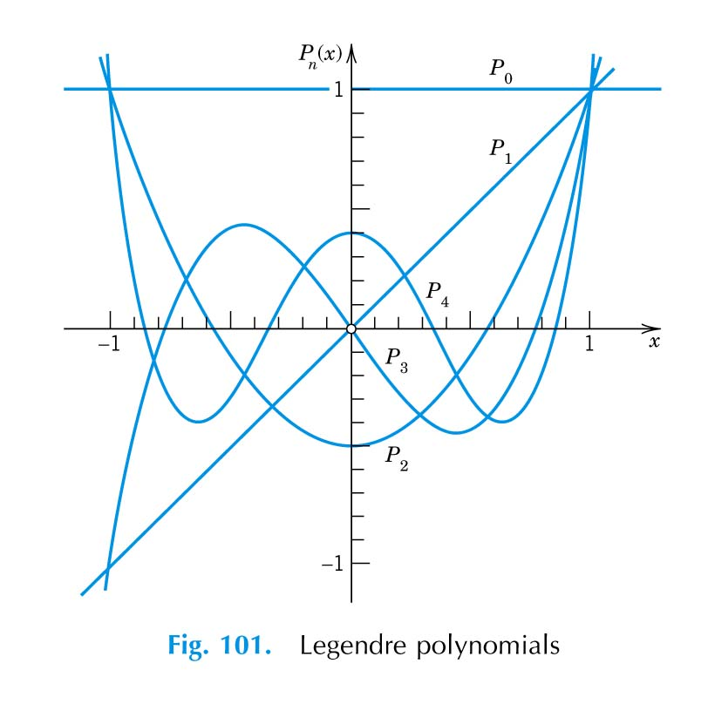

4.3 Legendre Functions of the Second Kind, Q_{n}(x)
( 1 − x² ) y'' − 2 x y' + n ( n + 1 ) y = 0, n = 0, 1, 2, . . .
⇒ y = c₁ P_{n}(x) + c₂ Q_{n}(x)
Q_{n}(x) can be obtained by the method of reduction of order:
Let
Let

If , then
Also,
Thus
Q₀(x) = ln = x + + + . . .

If n=1, then
Also,
Thus,
= x − 1

Note the most important property of Q_{n}(x) is that
Q_{n}(±1) = unbounded!!

4.4 Some Important Properties of P_{n}(x)
(1) Values of P_{n}(x)
P_{n}(1) = 1
P_{n}(−1) = (−1)^{n}
P_{n}(−x) = (−1)^{n} P_{n}(x)
n : even, P_{n}(x) : even function†
n : odd, P_{n}(x) : odd function
P_{n}'(−x) = (−1)^{n+1} P_{n}'(x)
(2) Rodrigues' Formula (Textbook p. 209, Prob. 6)
P_{n}(x) = [ ( x² − 1 )^{n} ]
[Exercise] Show that P₂(x) =
(3) Generating Function for Legendre Polynomials (Textbook p. 209, Prob. 10)
= P_{n}(x) t^{n}
(4) Recurrence Formulas (Textbook p. 210, Prob. 10(d))
(i) ( n + 1 ) P_{n+1}(x) = ( 2 n + 1 ) x P_{n}(x) − n P_{n-1}(x), n = 1, 2, . . .
(ii) P_{n+1}'(x) − P_{n-1}'(x) = ( 2 n + 1 ) P_{n}(x)
[Exercise] starting with P₀ = 1, P₁ = x, calculate P₂, P₃, P₄, . . .
(5) Integrating Formulas (Textbook p. 237, Example 4, p. 242, Example 2)
(i) = n = 0, 1, . . .
(ii) P_{m}(x) P_{n}(x) dx = 0, m ≠ n, m, n ∈ N
(6) Solution to
+ cotθ + n ( n + 1 ) y = 0, n = 0, 1, . . .
is y = c₁ P_{n}(cosθ) + c₂ Q_{n}(cosθ) ( Exercise! )
Derivation of (4)(i)

Selection of Polynomial Coefficients
Let an be the coefficient of xn in Pn(x), and an+1 be the coefficient of xn+1 in Pn+1(x).
(n+1) Pn+1 - (2n+1) x Pn + n Pn-1 = 0
The coefficient of xn+1 in the above equation is given by
(n+1) an+1 - (2n+1) an=0
∴ an+1 = an
and an = an-1 = an-2 = ...
= a0
= ao
But a0 is the coefficient of x0 in P0(x) = 1, we have a0 = 1
ﬁ an =
5 Bessel's Equations
5.0 Gamma Function, Γ(α)
Definition:
Γ(α) ≡
Properties:
(i) Γ(α+1) = α Γ(α)
Γ(α+1) = = [ − e^{-t} t^{α} ] + α e^{-t} t^{α-1} dt = α Γ(α)
(i)' Γ(α) = , n ∈ N
(ii) Γ(1) = 1 (from definition!) Γ(2) = 1, Γ(3) = 2 !, . . .
Γ(n) = ( n − 1 ) !, n ∈ positive integer N
(iii) Γ(1/2) = ;
Γ(3/2) =
(iv) Γ(−n) = ± ∞ n ∈ N
v) Plots of Γ(x):
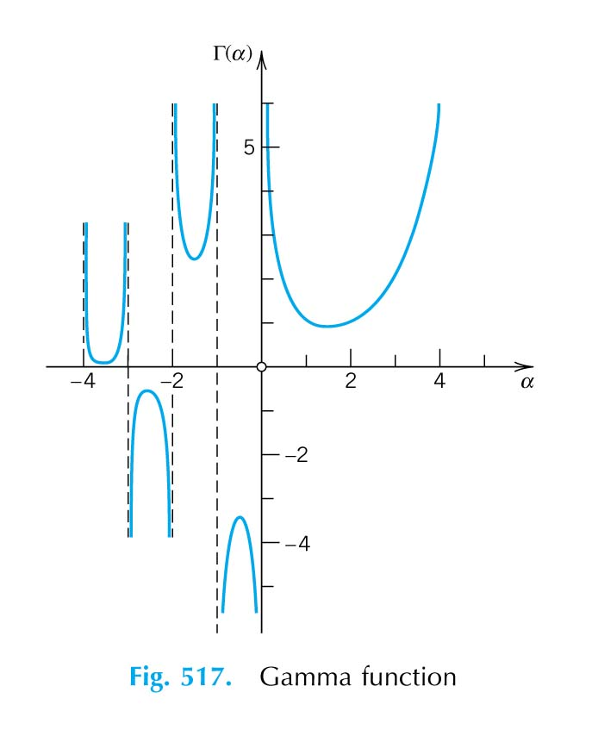

5.1 Bessel's Differential Equation
x² y'' + x y' + ( x² − ν² ) y = 0
where ν ≥ 0. Note that in this differential equation, p(x) = x/x² = 1/x is not analytic at x = 0, thus we have to assume
y = a_{m} x^{r+m}
⇒ Indicial Equation:
( r + ν ) ( r − ν ) = 0
or r₁ = ν and r₂ = − ν

(i) Solution for r₁ = ν
a₁ = 0 m = 1
a_{m} = a_{m-2} m ≥ 2
thus, a₁ = a₃ = a₅ = . . . = 0
and a₂ = −
a₄ = =
. . .
a_{2m} = ; m = 1, 2, . . .
∴ y₁(x) = a₀ x^{ν} + a₀ x^{ν}
We let
a₀ =
⇒ y₁(x) = J_{ν}(x) = x^{ν}
= Bessel Function of the First Kind of Order ν
For ν = n ≥ 0, n : integer
J_{n}(x) = x^{n}

Read p. 228, fig. 84 for plots of J₀, J₁ ... versus x. Note that
J₀(0) = 1
J₁(0) = J₂(0) = . . . = 0
J₀(∞) = J₁(∞) = . . . = 0

(ii) Solution for r₂ = − ν
r₁ − r₂ = 2ν
Recall that
y₂ = k y₁(x) lnx + x
k = 1, if r₁ − r₂ = 0
k may be zero if r₁ − r₂ ≠ 0, but r₁ − r₂ ∈ I

Also that we have illustrated

(a) x² y'' + x y' + [x² − (1/2)² ] y = 0
r₁ = , r₂ = − , r₁ − r₂ = 1, but
y₁ = , y₂ = ,
In this case, k = 0.

(b) x² y'' + x y' + ( x² − 1 ) y = 0
r₁ = 1, r₂ = − 1, r₁ − r₂ = 2, and
y₁ = x a_{m} x^{m} ; y₂ = y₁ ln x − x⁻¹ + . . .
In this example, k ≠ 0.

In general, substitute r₁ = ν into y₁ = a_{m} x^{m+r}, we have
y₁ = J_{ν}(x)
Similarly, substitution of r₂ = − ν into y₂ = a_{m} x^{m+r} gives
y₂ = J_{-ν}(x)
Are J_{ν}(x) and J_{-ν}(x) linearly independent?

Case 1 ν ∉ N
J_{ν}(x) and J_{-ν}(x) are linearly independent. In this case, the general solution of the Bessel differential equation is
y = c₁ J_{ν}(x) + c₂ J_{-ν}(x), ν ∉ N

Case 2 ν ∈ N { 0, 1, 2, ...}
It can be shown that (Exercise! Also read p. 230, theorem 2 of the textbook.)
J_{-n}(x) = (−1)^{n} J_{n}(x)
i.e., J_{-n} and J_{n} are linearly dependent, we need to find the second linearly independent solution by assuming (or by method of reduction of order)
y₂ = k (ln x) y₁ + x, x > 0
It yields (try this as an exercise!)
y₂ = J_{n}(x) ln x −
−
−
where h_{n} = 1 + + + . . . +

It is customary to replace y₂ by the linear combination of solutions
Y_{n}(x) = { y₂(x) + ( γ - ln 2 ) J_{n}(x) }, n = 0, 1, 2, ...
where γ = lim= 0.5772156649 = Euler Constant.
Y_{n} is called the Bessel function of the second kind of order n or the Neumann's function of order n.
Thus, the general solution for ν = n ∈ N is
y(x) = c₁ J_{n}(x) + c₂ Y_{n}(x)
Plots of Y₀ and Y₁ vs. x can be found in Fig. 105, p. 231 of the textbook. Note that for all integer n, Y_{n}(0) = − ∞ and Y_{n}(∞) = 0.
The function Y_{n} can be extended to all real numbers ν ≥ 0 by letting
Y_{ν}(x) = [ J_{ν}(x) cos νπ − J_{-ν}(x) ], ν ≠ 0, 1, 2-0
Y_{n}(x) = limY_{ν}(x)
In general, the general solution of Bessel's equation of order ν (regardless whether ν is integer or not) can be written as
y(x) = c₁ J_{ν}(x) + c₂Y_{ν}(x)

[Example] x² y’’ + x y’ + ( x² − 1/4 ) y = 0
[Solution] y = c₁ J+ c₂ Y
or y = c₁ J+ c₂ J
(You have to specify what J_{1/2}, Y_{1/2}, J_{-1/2} are in your answer.)
[Example] x² y’’ + x y’ + ( x² − 1 ) y = 0
[Solution] y = c₁ J₁(x) + c₂ Y₁(x)
but not y = c₁ J₁(x) + c₂ J₋₁(x)
since J₁(x) and J₋₁(x) are linearly dependent!

Plots of J₀, J₁, Y₀, Y₁ are given in the following figures:
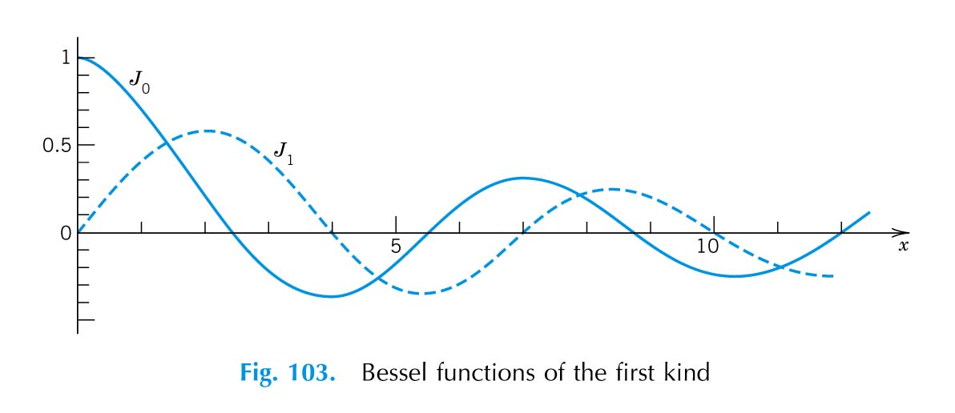

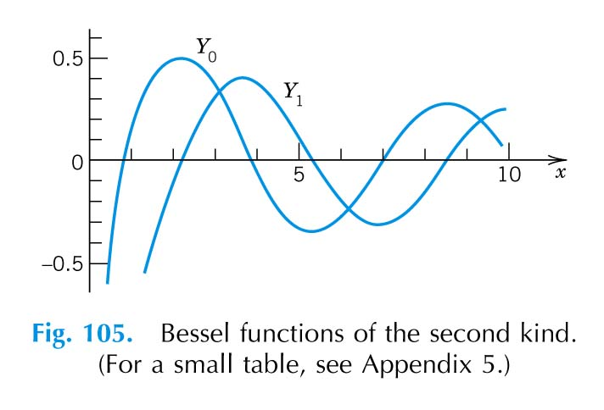

5.2 Bessel’s Equations of Order ν with Parameter λ
x² y'' + x y' + ( λ²x² − ν² ) y = 0
Let t = λ x
dy/dx = λ dy/dt, d²y/dx² = λ² d²y/dt²
∴ t² + t + ( t² − ν² ) y = 0
⇒ y = c₁ J_{ν}(t) + c₂ Y_{ν}(t)
or y = c₁ J_{ν}(λx) + c₂ Y_{ν}(λx)
If ν is not a positive integer or 0, then the solution can be also written as
y = c₁ J_{ν}(λx) + c₂ J_{-ν}(λx)

  - Modified Bessel's Functions
(Problems 14 ~ 16 on p. 232 in the Textbook)
x² y'' + x y' − ( x² + ν² ) y = 0 (1)
Note that the solution of x² y'' + x y' + ( λ²x² - ν² ) y = 0 is given by
y = c₁ J_{ν}(λx) + c₂ Y_{ν}(λx)
In this case, λ = i, λ² = − 1, thus the solution of (1) is
y = c₁ J_{ν}(ix) + c₂ Y_{ν}(ix)
But J_{ν}(ix) =
= i^{ν}
∴ we let
I_{ν}(x) ≡ i^{-ν} J_{ν}(ix) = Modified Bessel's Function of the First Kind of Order ν

If ν is not an integer, the general solution of
x² y'' + x y' − ( x² + ν² ) y = 0
is given by
y = c₁ I_{ν}(x) + c₂ I_{-ν}(x)

If ν = n, an integer, then
I_{n}(x) = I_{-n}(x)
We now define
K_{ν}(x) ≡
= Modified Bessel's Function of the second kind with order ν
For ν = n, K_{n}(x) = lim

In summary, the general solution of
x² y'' + x y' − ( x² + n² ) y = 0
is y = c₁ I_{n}(x) + c₂ K_{n}(x)
and that

the general solution of
x² y'' + x y' − ( x² + ν² ) y = 0 , ν ∉ I
is given by
y = c₁ I_{ν}(x) + c₂ I_{-ν}(x)
or y = c₁ I_{ν}(x) + c₂ K_{ν}(x)
Note that I_{n}(∞) = ∞ K_{n}(∞) = 0
I₀(0) = 1 K_{n}(0) = ∞
I₁(0) = 0

5.4 Equations Solvable in Terms of Bessel Functions
( Do Exercises 1~10 on p. 226 and Exercise 2~10 on p. 232 of the Textbook! )

- If ( 1 − a )² ≥ 4 c and if neither d, p nor q is zero, then (except the Euler Equation),
x² y'' + x ( a + 2 b x^{p} ) y' + [ c + d x^{2q} + b ( a + p − 1 ) x^{p} + b² x^{2p} ] y = 0
has the complete solution
y = x^{α} e^{-β}[ c₁ J_{ν}(λx^{q}) + c₂ Y_{ν}(λx^{q}) ]
where
α = , β =
λ = , ν =
If d < 0, J_{ν} and Y_{ν} are to be replaced by I_{ν} and K_{ν}, respectively.

(ii) If ( 1 - r )² ≥ 4 b, a ≠ 0 and if either r - 2 < s or b = 0, then (except for Euler Equation)
( x^{r} y’ )’ + ( a x^{s} + b x^{r-2} ) y = 0
has a complete solution
y = x^{α} [ c₁ J_{ν}(λx^{r}) + c₂ Y_{ν}(λx^{r}) ]
where
α = , γ =
λ = , ν =
If a < 0, J_{ν} and Y_{ν} are to be replaced by I_{ν} and K_{ν}, respectively.

(iii) x² y’’ + a x y’ + ( b x^{c} + d ) y = 0
⇒ y = c₁ x^{α} J_{ν}(λx^{β}) + c₂ x^{α} Y_{ν}(λx^{β})
where
α = β =
λ² = ν² =

[Example] x² y’’ + a x y’ + ( b x^{c} + d ) y = 0
[Solution] Let y = u x^{α}
y’ = α u x^{α-1} + u’ x^{α}
y’’ = α ( α − 1 ) u x^{α-2} + α u’ x^{α-1} + α u’ x^{α-1} + u’’ x^{α}
= u’’ x^{α} + 2 α x^{α-1} u’ + α ( α − 1 ) u x^{α-2}
Thus, the differential equation becomes
x² ( u'' x^{α} + 2 α x^{α-1} u' + α ( α − 1 ) u x^{α-2} )
+ a x ( α u x^{α-1} + u' x^{α} ) + ( b x^{c} + d ) u x^{α} = 0
or x² u'' + ( 2 α + a ) x u' + { b x^{c} + α ( α − 1 ) + a α + d } u = 0
Compare the above equation with the standard form of the Bessel's differential equation
x² y'' + x y' + ( λ²x² − ν² ) y = 0
we set 2 α + a = 1
⇒ x² u'' + x u' + { b x^{c} + d − α² } u = 0
Next, we set
z² = x^{c} or z = x^{c/2}
then u' = = = x
u'' = =
= x+ x
= x+ x
After substitution u' and u'' into the differential equation, we have
z² + z + u = 0
Again, compare with the standard Bessel's differential equation, we can set
λ² = ; ν² =
and the solution is thus
u = c₁ J_{ν}(λz) + c₂ Y_{ν}(λz)
but y = u x^{α} , z = x^{c/2} = x^{β}
∴ y = c₁ x^{α} J_{ν}(λx^{β}) + c₂ x^{α} Y_{ν}(λx^{β})
where α = ( a = 1 − 2 α )
β =
λ² = ( λ² β² = b )
ν² = ( α² − ν² β² = d )
[Exercise] Try to use the substitutions
y = u x^{1/2} and z = x^{1/2}
to find the solutions (in terms of Bessel's functions) to the following differential equation
x y'' + y = 0
[Answer] y = c₁ J₁( 2) + c₂ Y₁( 2)
5.5 Some Important Properties of Bessel Functions
(A) Identities
(1) = x^{ν} J_{ν-1}(x) (Read p. 223 of the Textbook)
(2) = - x^{-ν} J_{ν+1}(x) ( " " )
(1)_{Y} = x^{ν} Y_{ν-1}(x)
(2)_{Y} = − x^{-ν} Y_{ν+1}(x)
(1)_{I} = x^{ν} I_{ν-1}(x)
(2)_{I} = x^{-ν} I_{ν+1}(x)
(1)_{K} = − x^{ν} K_{ν-1}(x)
(2)_{K} = − x^{-ν} K_{ν+1}(x)
(3) J_{ν-1}(x) + J_{ν+1}(x) = J_{ν}(x) (p. 224 of the Textbook)
(4) J_{ν-1}(x) - J_{ν+1}(x) = 2 J_{ν}' (x) ( " " )
(5) x^{ν} J_{ν-1}(x) dx = x^{ν} J_{ν}(x) + C
(6) x^{-ν} J_{ν+1}(x) dx = − x^{-ν} J_{ν}(x) + C
(7) J_{ν+1}(x) dx = J_{ν-1}(x) dx − 2 J_{ν}(x)

Applications of the Above Identities

[Example] Express J₄(λx) in terms of J₀(λx) and J₁(λx)
[Solution] It is known that
∴
⇒ J₄(λx) = J₃(λx) − J₂(λx)
J₃(λx) = J₂(λx) − J₁(λx)
J₂(λx) = J₁(λx) − J₀(λx)
⇒ J₄(λx) = J₁(λx) - J₀(λx)

[Exercise] Show that
x J₀(x) dx = x J₁(x) + C
J₁(x) dx = - J₀(x) + C

[Example] Evaluate J₃(x) dx
[Solution] J₃(x) dx = x² [ x⁻² J₃(x) ] dx
⇓ ⇓
u dv
u = x² ; dv = x⁻² J₃(x) dx = d( − x⁻² J₂(x) )
Integration by parts:
J₃(x) dx = − x² ( x⁻² J₂(x) ) + x⁻² J₂(x) dx²
= − J₂(x) + 2 x⁻¹ J₂(x) dx
= − J₂(x) - 2 x⁻¹ J₁(x) + C

[Example] dx
=
⇓ ⇓
u dv
du = (3x)² J₁(3x) 3 dx ; (Recall the Identity (1))
v = −

∴ dx
=
=
⇓ ⇓
u dv
u = 3 x J₁(3x) ; dv = dx/x²
du = 3x J₀(3x) 3 dx ; v = − 1/x
∴ dx
=
= − − J₁(3x) + 3 J₀(3x) dx

In general, an integral of the form
x^{m} J_{n}(x) dx m+n 0
- completely integrated if m + n = odd,
- have for m + n = even.

(B) Behavior Near the Origin
n = 0 J₀(0) = I₀(0) = 1
Y₀(0) = - ∞
K₀(0) = ∞
n = 1, 2, ... J_{n}(0) = I_{n}(0) = 0
Y_{n}(0) = - ∞
K_{n}(0) = ∞
(C) Asymptotic Behavior for Large x
J_{n}(x) ≈ cos( x − − )
Y_{n}(x) ≈ sin( x − − )
(D) Bessel Function of Half Integer Order
J= sin x (Read p. 224 of the Textbook.)
J= cos x
I= sinh x
I= cosh x
(E) Bessel Function of Negative Order, n ∈ N
J_{-n}(x) = (−1)^{n} J_{n}(x)
Y_{-n}(x) = (−1)^{n} Y_{n}(x)
I_{-n}(x) = I_{n}(x)
K_{-n}(x) = K_{n}(x)

Summary
1 f(x) = ^{m} Taylor Series
When x₀ = 0 ⇒ Maclaurin Series
2 Ratio Test
ρ = lim
3 Analytic Function, Regular Point, Singular Point, etc.
y'' + p(x) y' + q(x) y = 0
If p(x), q(x) are analytic at x = 0 ⇒ x = 0 is a regular point
⇒ y = a_{m} x^{m}
If p(x), q(x) are not analytic at x = 0 ⇒ singular point
For x = 0 is a singular point, rewrite the differential equation in the following form:
y'' + y' + y = 0
If b(x), c(x) analytic at x = 0 ⇒ regular singular point
⇒ y = x^{r} a_{m} x^{m}
If b(x), c(x) not analytic ⇒ irregular singular point
4 Frobenius Method - Extended Power Series Method
Any differential equation of the form
y'' + y' + y = 0
where b(x) and c(x) are analytic at x = 0, has at least one solution of the form
y = x^{r} a_{m}x^{m} = x^{r} ( a₀ + a₁x + a₂ x² + ... ), a₀ ≠ 0
where r may be any number ( real or complex ).

Form of the Second Solution
Case 1: r₁ and r₂ differ but not by an integer
y₁ = x
y₂ = x
Case 2: r₁ = r₂ = r, r =
y₁ = x^{r} ( a₀ + a₁ x + a₂ x² + . . . )
y₂ = y₁ ln x + x^{r} (A₁ x + A₂ x² + . . . )
Case 3: r₁ and r₂ differ by a nonzero integer, where r₁ > r₂
y₁ = x
y₂ = k y₁ ln x + x
where r₁ − r₂ > 0 and k may be zero.
Note that in Case 2 and Case 3, the second linearly independent solution y₂ can also be obtained by reduction of order method ( i.e., by assuming y₂ = u y₁ ).
1. Legendre's Differential Equation
( 1 - x² ) y'' - 2 x y' + n ( n + 1 ) y = 0 , n = 0, 1, 2, . . .
y = c₁ P_{n}(x) + c₂ Q_{n}(x)
where P_{n}(x) = Legendre polynomials
Q_{n}(x) = Legendre functions of the second kind
2. x² y'' + x y' + ( x² - ν² ) y = 0
(1) ν ∈ N ( ν = n )
y = c₁ J_{n}(x) + c₂ Y_{n}(x)
y = c₁ J_{n}(x) + c₂ J_{-n}(x) ⇐ No!
(2) ν ∉ N
y = c₁ J_{ν}(x) + c₂ Y_{ν}(x)
or y = c₁ J_{ν}(x) + c₂ J_{-ν}(x)
Need to specify J and Y . . .
3. x² y'' + x y' + ( λ² x² - ν² ) y = 0
(1) ν ∈ N ( ν = n )
y = c₁ J_{n}(λx) + c₂ Y_{n}(λx)
y = c₁ J_{n}(λx) + c₂ J_{-n}(λx) ⇐ No!
(2) ν ∉ N
y = c₁ J_{ν}(λx) + c₂ Y_{ν}(λx)
or y = c₁ J_{ν}(λx) + c₂ J_{-ν}(λx)
Need to specify J and Y . . .
4. x² y'' + x y' - ( x² + ν² ) y = 0
(1) ν ∈ N ( ν = n )
y = c₁ I_{n}(x) + c₂ K_{n}(x)
y = c₁ I_{n}(x) + c₂ I_{-n}(x) ⇐ No!
(2) ν ∉ N
y = c₁ I_{ν}(x) + c₂ K_{ν}(x)
or y = c₁ I_{ν}(x) + c₂ I_{-ν}(x)
Need to specify I and K . . .
5. J₀, J₁, Y₀, Y₁, I₀, I₁, K₀, K₁ 之 圖 形

